Budget and Account Checking
We've introduced an upgrade that allows you to conveniently check and reconcile your budget accounts. Simply follow the instructions below:
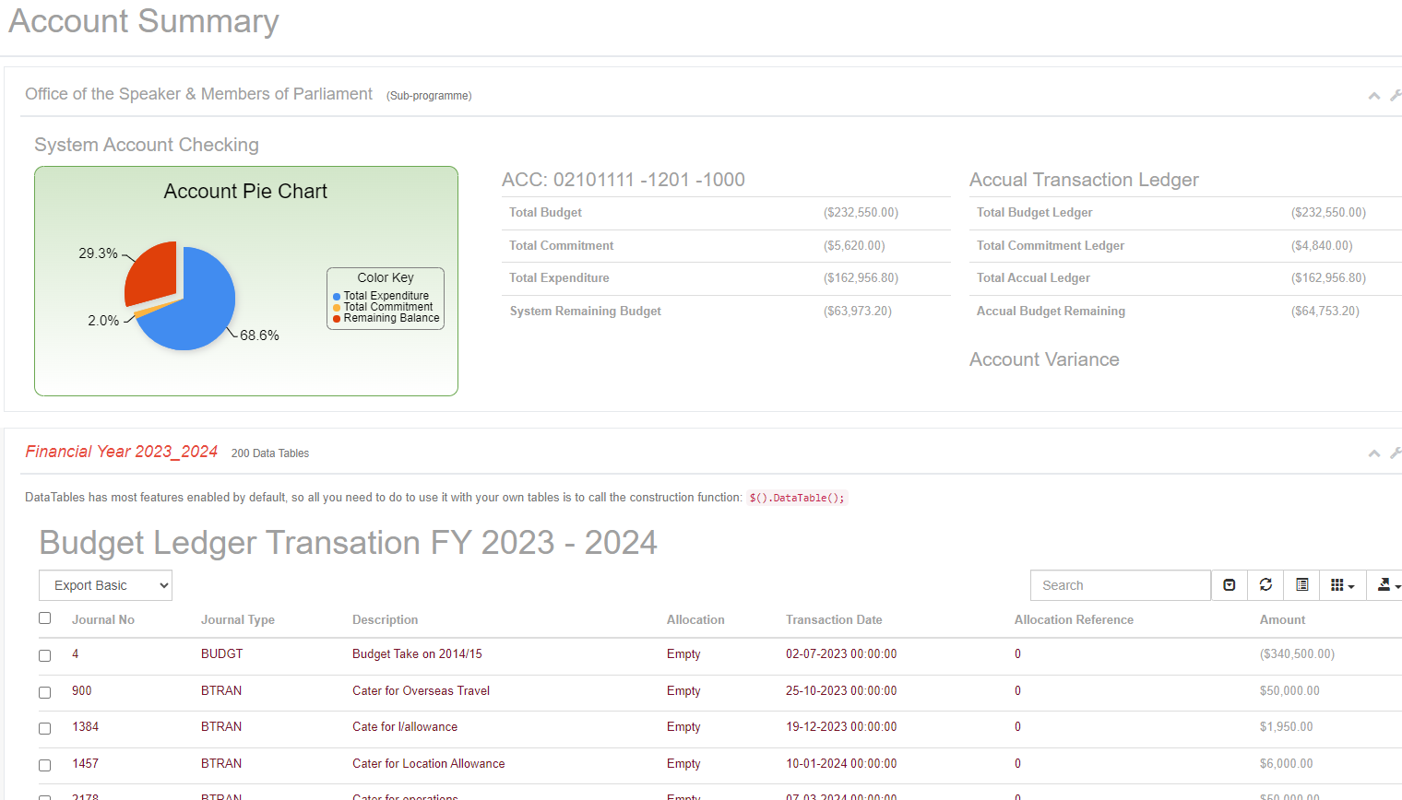
- Accessing the Budget Estimates: Users are instructed to access the budget estimates for the years 2023-2024 by clicking on a link in the left-side menu. This link likely leads to a dropdown menu where they can select the "Department budget" option.

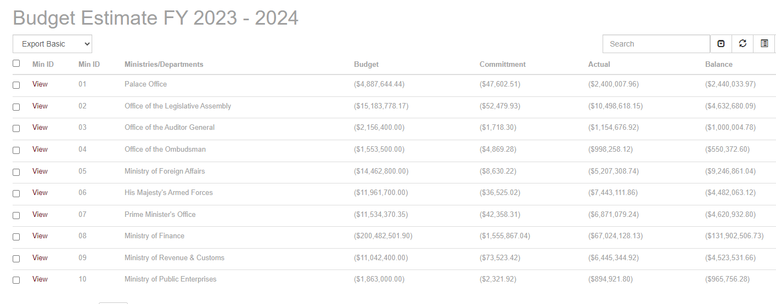
- Selecting Department and Organization: Once the user selects the department budget, they will likely be directed to a page displaying the budget estimates for various departments or organizations. The user can then choose the specific department or organization they wish to view the budget for by selecting the corresponding department ID from a column.
- Viewing Account Details: After selecting the department or organization, the system will likely provide the user with the details of the accounts associated with that department or organization. The user can select a specific account number to view the details of transactions related to that account.
- Transaction Details: The system will then display various details related to the selected account, including:
  - Actual Ledger: Details of current payments made.
  - Commitment Ledger: Details of expenditures that have been committed but not yet paid.
  - Budget Ledger: Details of budget transactions since the beginning of the financial year.
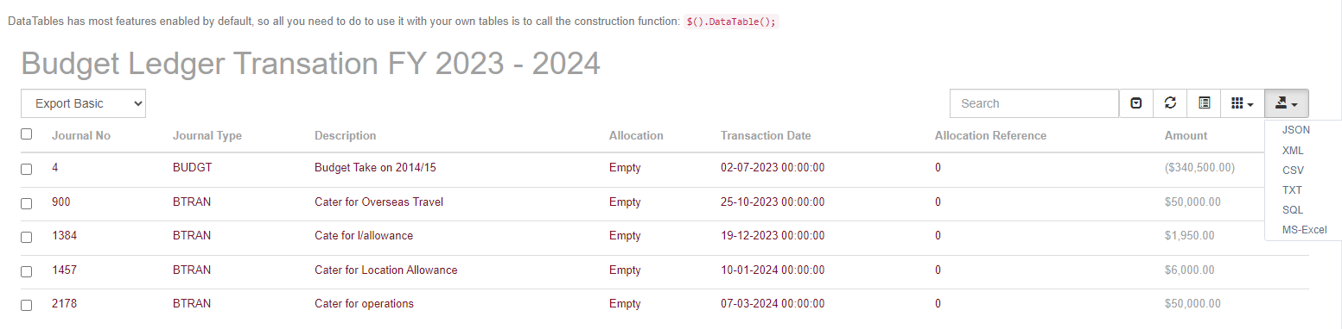

Downloading Table Contents
To download table data, follow these steps:
- Navigate to the top right corner of the table.
- Click on the dropdown link.
- Select the appropriate format for downloading the data.

