Support Portal User Manual
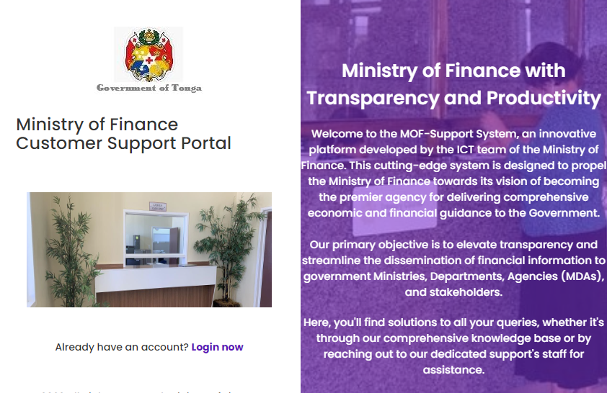

Login
To login, just click on Login now link, to flip the page to login form as appear below.
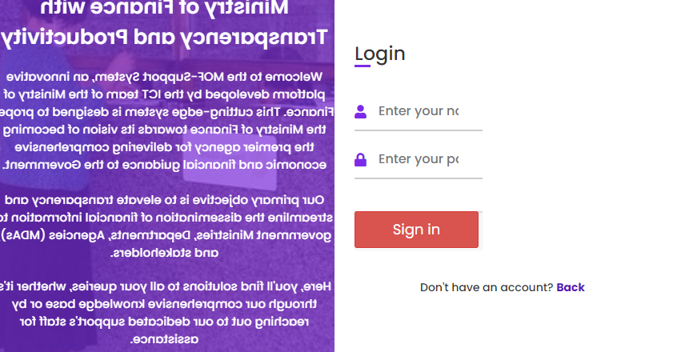
Type in your user name and password, then click on Sign in button.

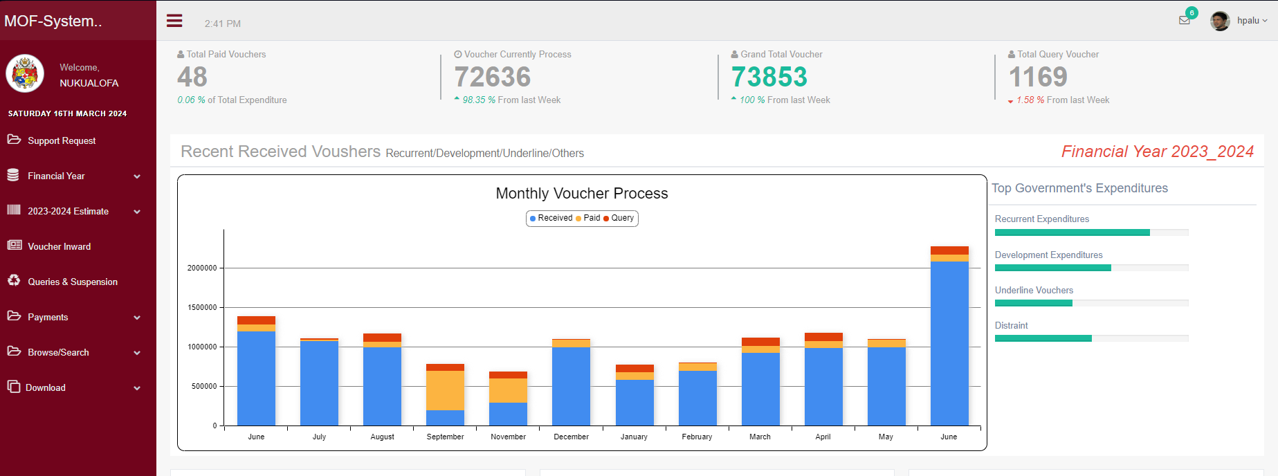
After signing in, the system will direct you to the homepage where only the appropriate access will be displayed to based on your pensions.

Submitting a support request ticket:
If you do not have access to the MOF support portal, you can navigate to the support portal by clicking on the corresponding link on the homepage. This will direct you to the ticket submission form page. Once there, click on the "Submit a ticket" button to access the submission form. Fill in all the required fields, then click "Submit.
.
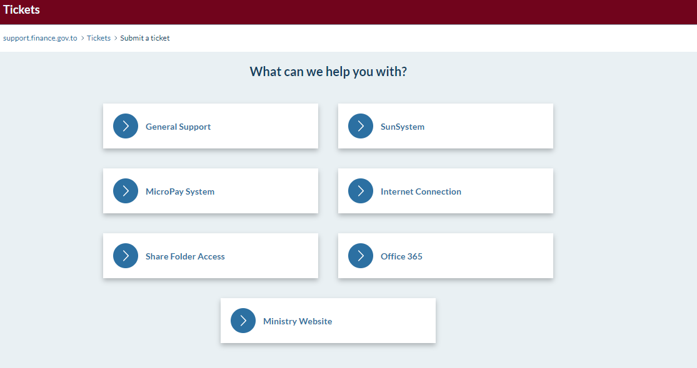

If you are already signed in to the system portal, simply click on the "Support request" menu on the left-hand side to be directed to the ticket submission form.

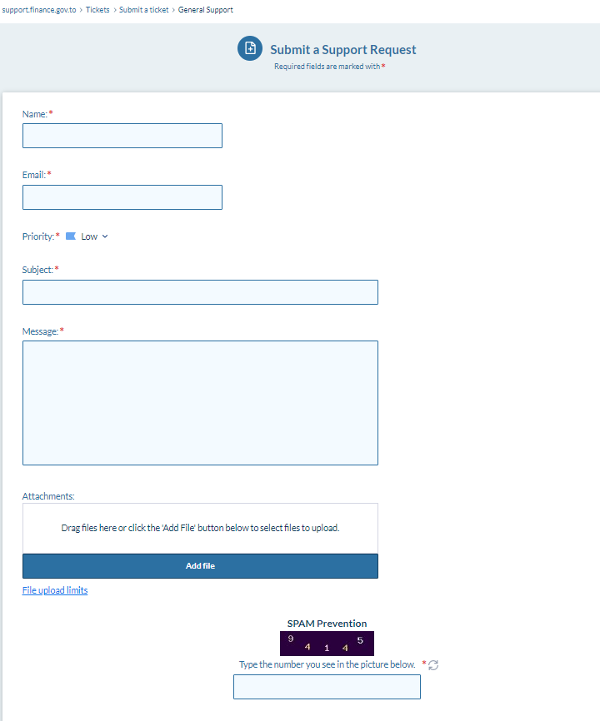
Note: fill all the require fields and the SPAM prevention before submitting your support tickets. Otherwise your tickets won’t submit.

